Estimating Carbon in Maine Trees and Forests
And Managing Strategies to Increase Carbon Sequestration
Mitch Lansky
August, 2018

Introduction.
There are two major strategies to help meet the Paris Agreement goals to limit destructive climate change; decrease carbon emissions and increase carbon sequestration (capturing and storing carbon). This document focusses in on the latter goal, but advocates for both at once—the double bottom line.

Article 5 of the Paris Agreement recognizes that “Parties should take action to conserve and enhance as appropriate, sinks and reservoirs of greenhouse gasses (…), including forests.” Maine has, at 89%, the highest percentage of forest of any state. The forests of Maine, even without a conscious governmental effort to increase carbon sequestration, are already making a significant contribution to reducing atmospheric carbon.

A Maine Department of Environmental Protection document, shows net sequestration by Maine forests, 2005-2015, as averaging the equivalent of 12.8 million metric tonnes (a metric tonne is 2205 pounds) of Carbon Dioxide (CO2). Another document, from the federal Energy Information Agency, has total CO2 emissions from fossil fuels burned in Maine for residential, commercial, industrial, electric power plants, and transportation for the same years as averaging at 14.9 million metric tonnes. This means the CO2 taken in by forest trees in Maine is the equivalent of 86% of the CO2 emitted by burning fossil fuels.

The forest contribution to sequestering carbon in Maine has been the result of Business as Usual (BAU), and is not a deliberate attempt to offset, or remediate, carbon emissions. If we are going to improve carbon sequestration in Maine forests, these figures should be considered a baseline.

The Carbon in your forest
How much carbon is in your forest? Where is it located? Can it be increased, and, if so, how?

To get an accurate estimate of the carbon in your forest would be a difficult, expensive undertaking, involving trained technicians taking samples, making measurements, and doing calculations. You can, however, make forest carbon estimates yourself for individual trees based on species and diameter, and you can make estimates for forest stands based on inventory data from a forester. Though these estimates are not necessarily accurate, they are in the realm of plausibility because the numbers are based on averages of USDA Forest Service inventory samples. All one needs for an individual tree is the species and diameter, and for a forest stand are cruise data indicating cords per acre of merchantable wood (the trunk or “bole”) by timber type.

Individual Tree Carbon Estimator
We’ll start our carbon estimating with an individual tree. The first step is to use a tape measurer to find the circumference of the tree in question at 4.5 feet from the ground (this is referred to as “diameter at breast height”). Dividing the circumference by pi (3.1415927) gives you the diameter.

Of course, tree volumes at a given diameter can vary greatly based on how crowded the stand is, how fertile the soil, how much sunlight the tree gets, and more. The spreadsheet we will use for our estimates (Maine Tree Carbon Estimator) is based on averages of trees of a given species group at given diameters, so, though not necessarily precise, it will give a rough but plausible estimate.

Carbon is in all parts of a tree, not just the bole. To find the total carbon in the tree, we need to find the weight of carbon in a whole tree—including tops, branches, foliage, stump, and coarse roots. There is no simple formula for translating the volume in the trunk to the volume (or weight) of the whole tree. The percentage of bole to whole tree increases as the tree diameter increases. The spreadsheet takes into account that change in ratio of the various tree carbon “pools” (reservoirs of carbon).

Based on tree diameter, the spreadsheet comes up with “green weight” of the total tree biomass. Much of that green weight is water, so we have to estimate dry weight (which I have extrapolated from 2009 USDA Forest Service data). Then, assuming that carbon is half the weight of dry wood, we can make our estimate of carbon in “short tons” (2,000 pounds). Or we can convert from tons to pounds (multiply by 2,000) if the tree is small. The spreadsheet does all of these calculations.

Unfortunately, the spreadsheet only calculates carbon for a limited number of species groups. In the various species groups, I have put in parentheses specific species for which the spreadsheet is calculating dry weight percentages. In some cases I used the average of two key species in the group.

Example—an 18 inch diameter white pine:
From the spreadsheet for individual tree biomass, we see that total green weight for an 18 inch white pine is 2.318 short tons. From the Forest Service data, dry pine wood weight is 60.5% of green wood weight. The dry wood weight of the pine is thus 2.318 x 0.605 = 1.402 short tons. And since carbon is one half of that dry wood, the weight of carbon is 1.402 x 0.5 = 0.701 short tons, or (multiplying by 2000) 1,402 pounds. But you don’t have to do those calculations—they are in the spreadsheet.

To find the growth rate (and pounds of carbon captured and stored per year) one would need to examine the growth rings by using a tool called an “increment borer.” One could, for example see how many growth rings there are in the last inch of growth. Since that growth occurs on both sides of the tree, that one inch represents a two inch diameter increment.

With the spreadsheet, you can see how much carbon was sequestered in the tree to produce that two inch increase. Subtract the two inch smaller total carbon from the most recent total carbon and divide by the number of years it took to reach that diameter increase. That would be the tree’s annual average carbon increase for that time period.

Maine Forest Carbon Estimator
We’ve just estimated carbon in a whole tree—both above and below ground. But measuring carbon in a forest involves more carbon pools than just those in a living tree. Indeed, with the average forest acre in Maine, whole living trees, including roots, trunks, tops and branches, only contain 35% of total forest ecosystem carbon.
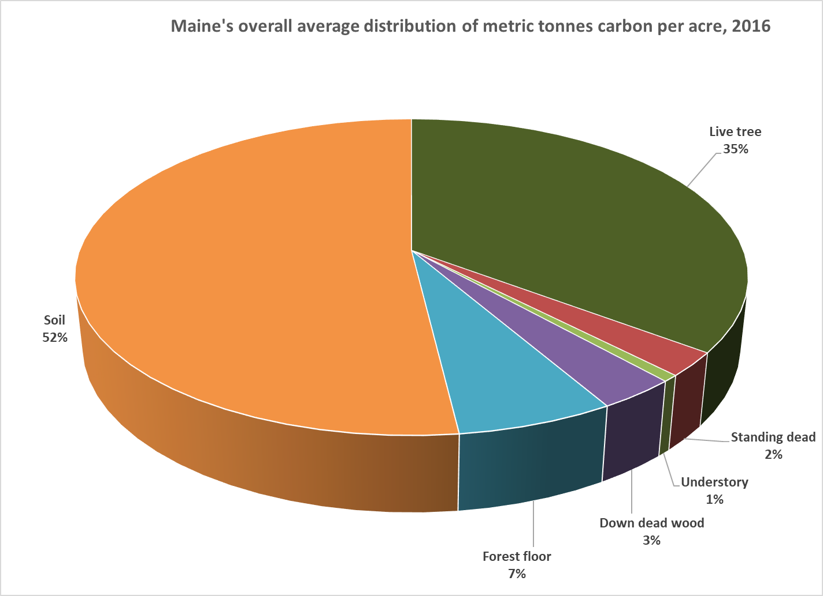

There is also carbon in standing dead trees, the understory, down dead wood, litter on the forest floor, and soil organic matter. Indeed, the soil in the average forested acre in Maine contains more than half the carbon in the forest.
The USDA Forest Service has developed a spreadsheet that shows how these carbon pools change in size and ratios as forests develop from clearcut to mature.

The Maine Forest Carbon Estimator is a tool to estimate total forest carbon based on stand age or merchantable stand volume. With it, one can take simple estimates of cords per acre of a forest and get an estimate of total ecosystem carbon by forest type. It will also give estimates for each carbon pool, such as live trees, dead wood, litter, and soil.

The Estimator was modified by Kenneth Laustsen, Biometrician for the Maine Forest Service, to incorporate new and revised carbon estimates of forest floor and soil from 2012-2016 USFS FIA Maine data. Some of Ken’s modifications were in response to questions and requests from me, and I thank him for his patience with my numerous questions and for his dedication to serving the public.

The spreadsheet was generated and published from plot data across the Northeast for similar forest types. This spreadsheet is constructed as though it were tracking natural forest growth after a clearcut harvest. The stand undergoes natural regeneration and development, remaining uncut for up to 125 years. Of course, most forest landowners would do some sort of thinnings in a 125 year rotation, but simulating partial cuts and regrowth would require a far more sophisticated and complicated program.

Although basing estimates on averages can lead to plausible results and probable trends, the forest plots used to get this average may have very different soils, slopes, aspects, and management histories from each other. The estimates may vary considerably from what is in an actual forest, especially if the forest is older than 125 years, has a higher volume than those listed, or contains uneven aged components.

How to use the estimator.
Start by opening the Maine forest carbon estimator, interactive
- Determine which major forest type group (7 choices) in the spreadsheet best resembles your forest stand in question. There are no mixedwood choices.
- Enter the number of acres of your forest type in column “N” in the corresponding row that matches volume in cords (Column “F”) to what is closest to your forest. If you are just trying to find average carbon per acre, enter “1” in that row.
- In the same row that you entered the number of acres, columns “O” through “T” now show estimates of metric tons of carbon per acre for the different carbon “pools.” These include Live Tree, Standing Dead, Understory, Down Dead, Forest Floor, and Soil (see second tab on bottom of the spread sheet with graphs for definitions of the 6 pools).
- Column “U” shows total ecosystem carbon in metric tons in the same row that you entered the acres.
- If you have entered multiple stands within the same major forest type, representing different ages or merchantable volume, then column “V” provides an overall average of the entire forest type.
- Columns x and y give calculations of growth in cords per acre per year and metric tonnes of carbon per acre per year for a given volume or age. Some of these calculations (i.e. negative growth) are questionable, due to insufficient data.
Example 1.
To figure out total ecosystem carbon in an acre of northern hardwood stand with 20 cords to the acre:
- Find section of spread sheet for maple, beech, yellow birch (rows 98 to 111).
- Find 20 cords in column “F.”
- Enter “1” in column “N,” in same row as 20 cords (row 103).
- Carbon pools, in metric tons, will show up in columns “O” through “T.” Total carbon in column “U,” (100.9 metric tons).
Example 2.
You can find out how much more carbon would be in the forest if it were allowed to grow for 20 years by entering “1” into column “N” two decades later (row 105). You can see the cords (column “F”, 28.9 cords), or total carbon (column “U,” 112.1 metric tons). You can subtract the first number from the second number for cords and find how much is changed (28.9 – 20.0= 8.9 cords), and divide that by 20 to calculate volume change per acre per year (8.9/20 = 0.445 cords per acre per year).

Example 3.
You can also subtract the first number from the second number for metric tons of carbon and find out how much of that is changed (112.1 – 100.9 = 11.2 metric tons), and divide that by 20 to calculate carbon change per acre per year (11.2/20 = 0.56 metric tons per acre per year). See section on conversions (towards end of this document) to see how the 0.56 metric tons of sequestered carbon dioxide compares to carbon emissions.

Example 4.
Or you can figure out the percent increase in carbon from increased stocking. In this case, the percentage increase is calculated by dividing the increase (11.2 metric tons) by the starting number (100.9 metric tons) to get the percent increase (11.2/100.6 = 0.11, or 11%).

Forest Carbon Pool Changes
For graphic representations of carbon pools of the average of the various forest types, open up Maine forest estimator graphs and look for tabs at the bottom of the spreadsheet. Table 1 has definitions of the various “pools.” There are also pie graphs (such as the one above showing distribution of carbon in an average Maine forest) and area graphs (see below), which show how the forest carbon pools change over time.
The ratios change as the stand develops. For example, if one looks at the changes over 125 years of the pine forest type, one can see that the biggest change over time is with live trees. The older the stand, the more carbon in live trees. The more carbon in live trees, the more carbon in the entire forest.
It is possible that other pools, such as dead wood or soil carbon, could change more than is shown in the data and in the graph of those data. The averaging out of varied sites with varied histories may be obscuring such possible trends.

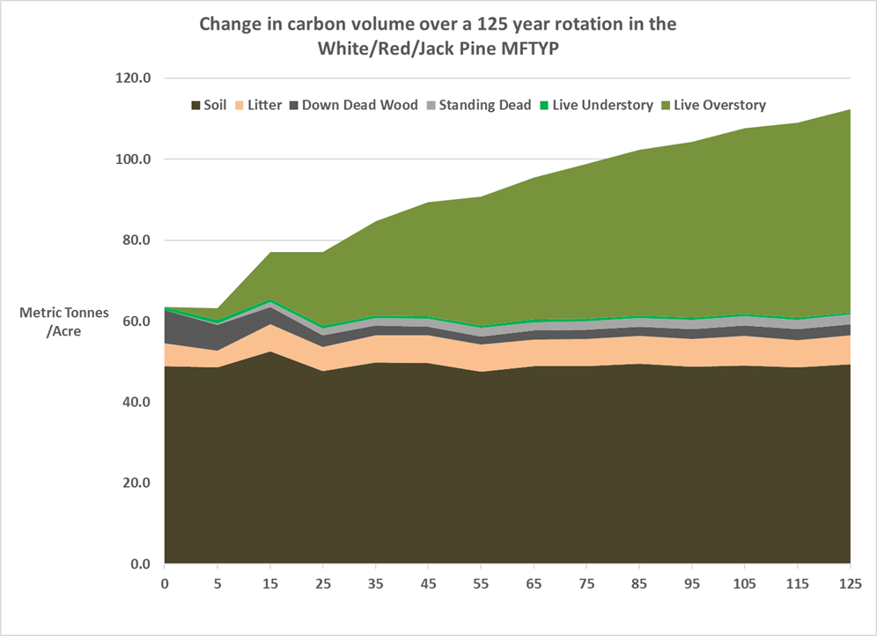
Strategies for increasing carbon in the forest landscape
The observation that increasing the average volume of live trees per acre is the prime way to increase carbon in a forested landscape has led to proposals of various strategies that can meet that goal:

- No cut. The most effective way to increase carbon in forests is to not cut the forests. “Reserved forests,” where there is no cutting allowed, currently make up only 3.8% of Maine’s forests. A review of strategies for increasing carbon sequestration in forests concluded that “Mean carbon sequestration was significantly (…) greater for ‘‘no management’’ compared to any of the active management scenarios.”

The spreadsheet shows what kind of increases can be expected up to 125 years. After that, forests start to acquire late-successional characteristics, including bigger trees, more dead standing and dead downed trees. Dead trees, especially larger diameter, can store carbon for many decades.

Compared with younger forests, older forests have a greater diversity of fungi, many of which form important partnerships with tree roots. These fungi (called “mycorrhizae”) increase intake of water and nutrients to the tree, and , in return, the trees supply carbon to the fungi. Research has found that big old trees are major contributors to carbon sequestration, and dead tree volume can continue to accumulate for centuries.

There is evidence that the passing of carbon through tree roots to fungi is a major source of carbon to lower soil levels. A recent study concluded that, “fungi have a bigger effect than most other factors, including the amount of plant growth, temperature, and rainfall” at storing carbon in forest soils. These fungi “exert major control on the global carbon cycle.”

Other research has shown that old growth forests can sequester a surprising amount of carbon into forest soils. Old growth and late-successional forests make up a tiny proportion of total regional forests. If we want to increase this proportion, it will take a many decades.

A review of management strategies concluded that, “even with consideration of C sequestered in harvested wood products, unmanaged northern hardwood forests will sequester 39 to 118% more C than any of the active management options evaluated. This finding suggests that reserve-based approaches will have significant C storage value.”

While “no cut” is considered a “passive” strategy, there are “active” management strategies that can also increase carbon sequestration, over time, over the forest landscape. The two most important variables are longer cutting cycles and/or lighter cuts, A review of cutting strategies concluded that, “Of the harvest treatments, those favoring high levels of structural retention and decreased harvesting frequency stored the greatest amounts of carbon.”

- Longer rotations. With even-aged management (leaving one or two age classes of trees), assuming that the age classes are balanced over the landscape, the forest landscape average volume from a longer rotation will hold more carbon than the average landscape volume from a shorter rotation.

You can test that assertion with the spreadsheet by looking at the average carbon over a short rotation versus a long rotation. To calculate the average carbon in a “regulated” forest (a forest with all age classes up to harvest age), take an average of the carbon from age zero to the carbon at the age of the rotation end. Researchers have used more sophisticated programs to come to the same conclusion.

With uneven-aged management (three or more age classes), managers can have longer cutting cycles—for example going from 15 year cycles to 30 year cycles. This would lead to developing higher volume stands before cutting back to the minimum residual stocking. If the residual stocking is the same for both the 15-year and 30-year cutting cycles, the average volume over a regulated landscape would be higher for the longer cutting cycle.

- Lighter cuts. With even-aged management, instead of cutting all the merchantable-sized trees (a total overstory removal), the manager can leave a portion of the trees to go another rotation. This “irregular shelterwood,” creates a two-aged stand. Repeated small partial cuts can create uneven aged stands.

Instead of averaging volume and carbon of mature stands with clearcut stands, the partial cut strategy averages out high volume stands with stands that are still stocked with mature trees, but a little bit less so. This strategy, even if the average annual growth is the same as for clearcut stands, could lead to significantly more average standing volume, and thus more landscape carbon.

One of the more important benefits of partial-cut strategies is the possibility of developing more complex structures that include larger trees and dead wood. Indeed, some researchers have explored ways to deliberately enhance the development of some of the structures found in late-successional forests.

One way to ensure the development of late-successional structure over time, especially those connected with large trees, is to identify “legacy trees” (the percentage of stands in such trees determined by management goals) that will not be cut at all, but would be allowed to get large, die, and eventually fall to the ground.

- Low-impact logging. The above strategies are forestry strategies and ignore how the forest is cut. This omission is most profound when considering partial cuts.
Whole tree logging (where trees are cut mechanically by a mechanical timber harvester and are skidded out in bunches, tops, branches, and all) is the most common logging system in the commercial forests of Maine. But, such a system is not ideal for leaving well-stocked stands that can develop crown closure.
Because of the limit of reach of the harvesters, logging trails can take up around 25% of the forest stand. In contrast, low-impact systems (using cable winches or animals to take wood to a forwarder) can take up less than 10% of the stand in trails, and the trails are narrower. This means that with low-impact operations, significantly more potential crop trees (20%) can be left to grow after the cut. Other benefits of low-impact approaches include less damage to residual trees (especially abutting trails), and less damage to the soil. All of these benefits would lead to more stand productivity over time. More residual volume and better growth mean more average carbon per acre over time over the landscape.
Single-grip processors (mechanical harvesters that delimb and cut trees to length in the woods) with forwarders (machines that carry, rather than drag ,the logs to the yard) can do less damage to residual stands and leave more residues than whole-tree technologies, though they still require an extensive trail system.
Some researchers have found that intensive, whole-tree clearcuts, that leave soil exposed and rutted, can lead to losses of soil carbon over time. If this is so, then lower-impact logging systems, combined with more retention that leaves more standing and down wood, and less damage to trees and soil, could make even more of a difference.
- Cut less than growth. A basic management goal to increase carbon levels over the landscape is to have a cut level, on a rolling ten year basis, that is less than growth. If landowners cut less than growth, stand volume will increase, and average size of trees will increase. This factor would favor managing for lumber that might continue to store carbon (in buildings) for many decades. If the cutting intervals are long enough, dead wood will also increase. The increase in volume of both live and dead wood will mean more stored carbon. Cutting less than growth is an investment in ecosystem development—as opposed to taking all growth for commercial purposes.
Example—Maine Public Reserved Lands:
Maine’s 600,000 acres of Public Reserved Lands have used a combination of the management strategies listed above, not for carbon, but to meet the multiple use mandates. These include not only timber, but also recreation, wildlife, and biodiversity.

70,000 acres are in ecological reserves and are not being cut. Most of the timberland is managed for uneven age. Except for short-lived timber types, even aged stands have rotations of more than a century. Cut has been less than growth for decades. The inventory is growing. As of 2016, the average volume per acre was 23.8 cords. Average growth per acre per year on Public Lands was 18% higher than the statewide average of 0.54 cords/acre/year.

The stocking volumes in Maine’s Public Forests are not that remarkable. The New England Forestry Foundation, which manages thousands of acres in a six-state region, averages 33 cords per acre on its forests.

According to the 2016 USDA Forest Service Forest Inventory & Analysis Unit, the average volume per acre of live trees for timberlands in the whole state (including Public Lands) was 17.9 cords. The Northern Maine Megaregion (Aroostook, Piscataquis, and Somerset Counties) had an average of 15.5 cords per acre. The state had a hardwood growth to cut ratio of 1. The Northern Megaregion had a hardwood growth to cut ratio of 0.8. Clearly there is room for improvement in timber volume and hardwood management in the Northern Maine Megaregion.

This example demonstrates that managing forests for multiple values can increase carbon over the landscape. Managing for forest carbon increase can also be done to benefit other forest values.

Conversions and comparisons.
Short ton = 2,000 pounds
Metric ton (or tonne) = 1000 kilograms= 2205 pounds
Weight of carbon dioxide compared to carbon—multiply weight of carbon by 3.67.
Note:
How could CO2, a gas, weigh more than carbon, a solid? CO2 is made of three atoms—one carbon and two oxygens. Oxygen (atomic number 8 and molecular weight of 16) weighs slightly more than carbon (atomic number 6 and molecular weight of 12). CO2 has a total molecular weight of 44 and carbon is 12; so 44/12 = 3.67; so 1 metric ton of sequestered carbon in the forest represents 3.67 metric tons of CO2 (Greenhouse Gas) sucked out of the atmosphere by trees during the photosynthetic process. Thankfully, trees then give most of the Oxygen back so we can breathe.

To help visualize the carbon numbers you estimate it helps to compare to something more familiar, such as car CO2 emissions.
- Convert metric tons of carbon to pounds of carbon (multiply by 2205).
- Convert pounds of carbon to pounds of CO2 (multiply by 3.67)
- A gallon of gasoline, when burned, converts to 20 pounds of CO2. A car that gets 30 miles per gallon emits 0.667 pounds of CO2 per mile. To find the miles a 30 mpg car has to go to emit a given amount of CO2, divide the CO2 (in pounds) by 0.667

Example: From example 3, we estimated that the northern hardwood stand was taking in 0.56 metric tons of carbon per acre per year. Converting that figure into pounds (x 2205) equals 1,235 pounds of carbon. Converting this to CO2 (x 3.67) equals 4,532 pounds of CO2. Dividing that number by 0.667 equals 6,794 miles driven by a car to emit the same amount of CO2 that the acre of hardwood forest sequesters each year.
Or one can compare the increased carbon stored in a forest to kilowatt hours of electricity generated by a fossil fuel power plant. 1 KWH of electricity represents 1.106 pounds of CO2 emissions. To find the KWH equivalent of CO2 sequestered in a forest, divide the CO2 by 1.106.
Example: Using the previous example, the 0.56 metric tons of carbon are equivalent to 4,532 pounds of CO2. Divide this by 1.106 gives us 4,098 kilowatt hours of electricity generated by burning fossil fuels.
A pre-1986 refrigerator uses 1400 kilowatt hours per year. The average CO2 sequestered per acre per year in the hardwood forest growing from 20 to 28.9 cords over a 20 year period would be the equivalent of close to 3 of these older refrigerators.
Rather than call this forest growth an “offset” to inefficient energy use, it would be better to find more efficient ways to generate and use energy. For example, one could switch from a car that gets 30 mpg to one that gets 40 mpg. Or drive fewer miles and use a bike or public transportation more. Or one could sell the old refrigerator and get an Energy Star rated newer model that only uses 350 kilowatt hours (75% less than the old model!). And also grow more wood in the woodlot by cutting less and leaving more while doing less damage to residual trees and soil. Such an approach would meet the double bottom line.
Policy Considerations
To be part of the solution to climate change, the level of sequestration would have to go up from the baseline as a result of deliberate policy, not just because of Business As Usual. This requirement is called “additionality.”

The policy of restraint, leading to more carbon in Maine forests, should not lead to heavier cutting, and thus less carbon, elsewhere. Passing the damage to elsewhere is called “leakage.”

Finally, the increase in forest carbon should be “permanent” (certainly more than 50 years) not merely a temporary increase to be erased in a few years by the next owner. The time scales for forest growth and development are much greater than normal human time scales. To create a legal incentive to maintain a carbon management agreement in “perpetuity” might require a property easement. But, to be really permanent would require having a societal culture that values our ecological life-support systems and passes these values on from generation to generation.

For more discussion on policy issues connected with increasing sequestration of carbon by forests and other ecosystems, see https://global.nature.org/initiatives/natural-climate-solutions

Acknowledgements
I would like to thank Ken Laustsen for generously sharing spreadsheets and time, and for making sure I was in the ballpark, but not out in left field.

Stock change (Oven-Dry Metric Tonnes Carbon) in Maine's forestland acreage between 2008 and 2016
State Carbon Dioxide Emissions Data, 2017
Source is Jenkins, J.C., D.C. Chojnacky, L.S. Heath, and R.A. Birdsey. 2004. Comprehensive database of diameter-based biomass regressions for North American tree species. General Technical Report NE-319. Newtown Square, PA: USDA, Forest Service, Northeastern Research Station. 45 p. Modified by M. Lansky
based on USFS 2009 https://www.nrs.fs.fed.us/pubs/rn/rn_nrs38.pdf
For the spreadsheet citation: Smith, J.E., L.S. Heath, K.E. Skog, R.A. Birdsey. Methods for calculating forest ecosystem and harvested carbon with standard estimates for forest types of the United States. General Technical Report Ne-343. Newtown Square, PA: U.S. Department of Agriculture, Forest Service, Northeastern Research Station. 216 p. modified by K.M. Laustsen to incorporate new Maine estimates of forest floor and soil organic carbon pools provided by Grant Domke in a personal communication on February 23, 2018.
Domke 2017 (https://www.nrs.fs.fed.us/pubs/55911
Ken Laustsen, personal communication
https://www.uvm.edu/giee/pubpdfs/Nunery_2010_Forest_Ecology_and_Management.pdf
https://www.sciencedaily.com/releases/2014/01/140115132740.htm
http://vnrc.org/wp-content/uploads/2012/08/VNRC-Old-Growth-pub.pdf
http://summitcountyvoice.com/2014/01/09/study-fungi-play-key-role-in-global-carbon-cycle/#more-62655 https://news.utexas.edu/2014/01/08/symbiotic-fungi-impact-carbon
http://faculty.jsd.claremont.edu/emorhardt/159/pdfs/2007/2_30_07.pdf
https://www.uvm.edu/giee/pubpdfs/Nunery_2010_Forest_Ecology_and_Management.pdf
https://www.uvm.edu/giee/pubpdfs/Nunery_2010_Forest_Ecology_and_Management.pdf
https://www.fs.fed.us/pnw/pubs/journals/pnw_2009_harmon001.pdf http://www.uvm.edu/giee/pubpdfs/Nunery_2010_Forest_Ecology_and_Management.pdf https://www.nrs.fs.fed.us/pubs/jrnl/2010/nrs_2010_nave_001.pdf
http://climatechange.lta.org/wp-content/uploads/cct/2017/04/Ford_et_al-2017-Ecosphere.pdf
https://extension.unh.edu/resources/files/Resource000429_Rep451.pdf
http://www.dartmouth.edu/press-releases/loggingdestabilizes120314.html http://www.nature.com/articles/srep15991
http://www.maine.gov/dacf/parks/publications_maps/docs/2017landsannualreport.pdf
http://newenglandforestry.org/wp-content/uploads/2018/02/NEFF-forestry-intro-2.pdf, page 5
State and Northern Megaregion data for 2016 from personal communication by Ken Laustsen of Maine Forest Service.

